DATABASE MANAGEMENT SYSTEMS

Project Abstract & Sql Queries

TITLE: NEW BORN CHILD DATA MANAGEMENT SYSTEM

Prepared and submitted by:

Kaviya.R.V

2019103538

B.E. Computer Science and Engineering.

**Functionalities of the database:**

* To maintain the database of the child born in various hospital.
* To maintain the record of the child.
* This will help us to know the whole details the children born in the city
* To know the Number of hospitals in the city
* To know the number of patients and doctors in hospital
* To know Availability and total number of rooms in hospital
* To maintain the separate records of each and every entities
* This will give complete information of a particular domain when enter that respective domain ID

**Relations used in the Database:**

**1)Mother:**

**Attributes:**

* Mother ID
* Mother Name
* Room number
* Hospital Name
* Age
* DOB
* City Name
* Child ID
* Doctor ID
* Bill ID

**Primary key:**

MotherID

**Foreign key:**

Hospital name(Hospital), Child ID(Child), Doctor ID(Doctor),City Name(City) ,Room Number(Rooms)

**2)Child:**

**Attributes:**

* Child ID
* Mother ID
* Born date
* Room number
* Doctor ID
* Blood group
* Sex
* Weight
* Hospital Name
* City Name

**Primary key:**

Child ID

**Foreign key:**

Hospital Name(Hospital), Doctor ID(Doctor), Room Number(Rooms) ,City Name(City)

**3)Doctor:**

**Attributes:**

* Doctor ID
* Doctor Name
* Hospital Name
* Child ID
* Mother ID
* Case ID
* City Name
* Cabin Number

**Primary Key:**

Doctor ID

**Foreign key:**

Hospital Name(Hospital) ,City Name(City)

**4)Hospital:**

**Attributes:**

* Hospital ID
* Hospital Name
* No of Rooms
* City Name
* Area
* No of Doctors
* No of Patients
* Ambulance Service Number
* Hospital Dean Name

**Primary key:**

Hospital ID, Hospital Name

**Foreign key:**

City Name(City)

**5)City:**

**Attributes:**

* City Name
* Hospital Name
* Hospital ID
* City Code
* No of Hospitals

**Primary key:**

City Name

**6)Bills:**

**Attributes:**

* Bill ID
* Bill Amount
* Mother ID
* Doctor Fee
* Medicinal Expenses
* Room Fee
* Tax Amount

**Primary key:**

Bill ID

**Foreign key:**

MotherID(Mother)

**7)Rooms:**

**Attributes:**

* Room Number
* Floor Number
* Block Name
* Room Check
* Availability

**Primary key:**

Room Number

All attributes in all the tables are non-transitively determined by the Primary key(Super key) of the respective tables. Hence the tables in this relation are in **BOYCE-CODD NORMAL FORM.**

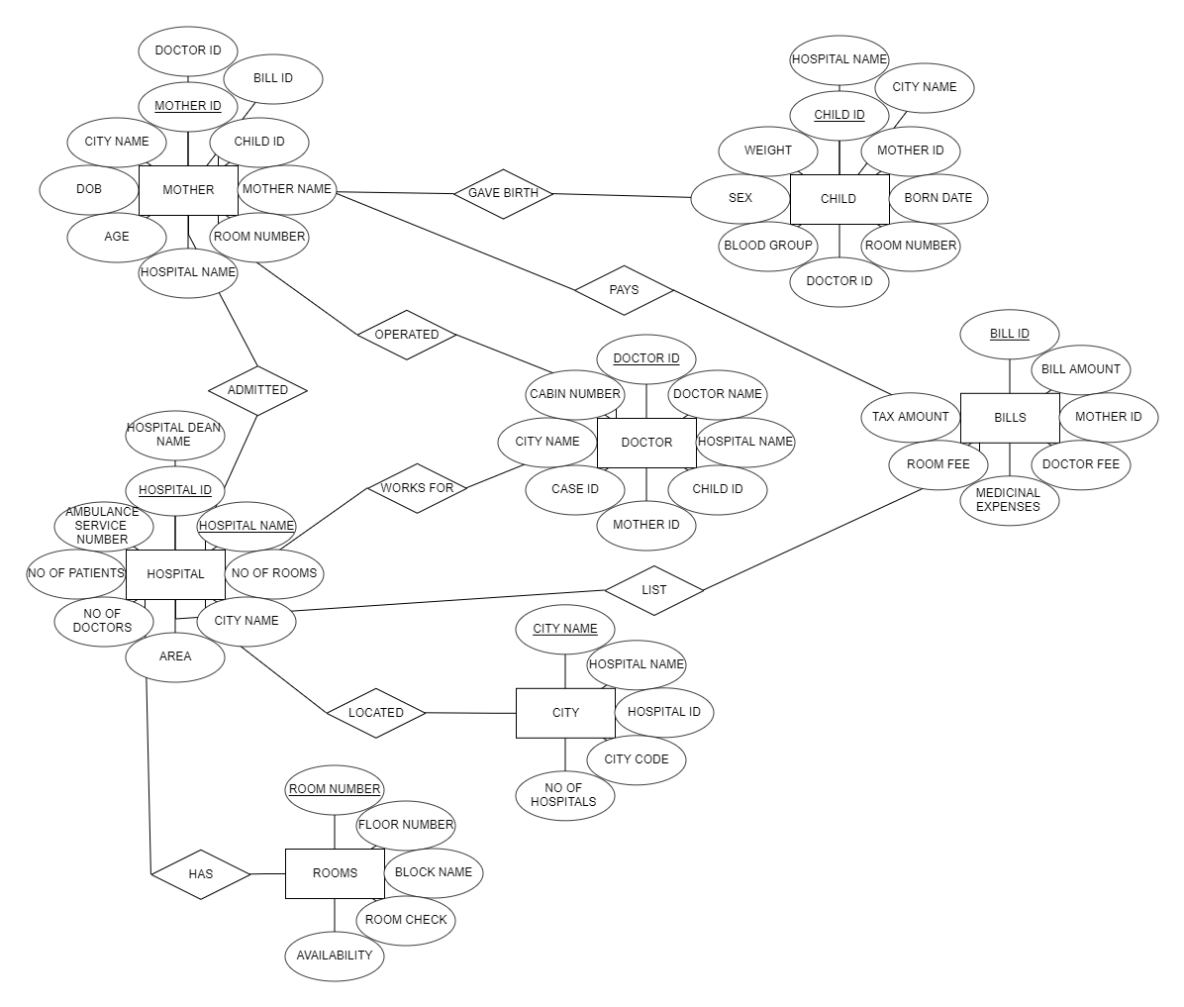

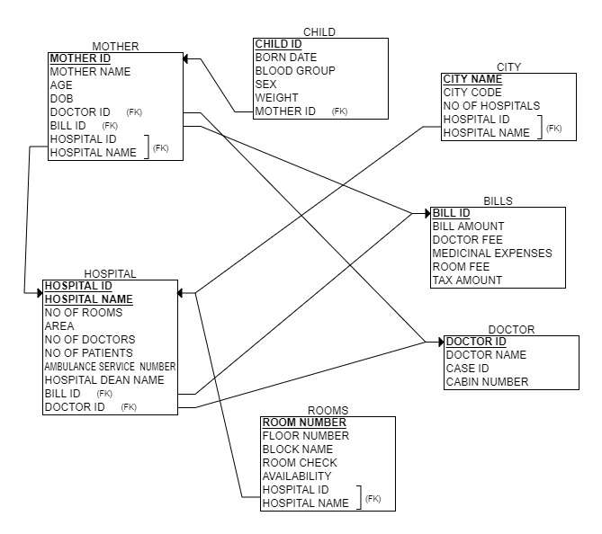

**SQL Queries:**

**1.BILLS:**

**CREATE TABLE `bills` (**

**`BillID` int NOT NULL,**

**`BillAmount` int NOT NULL,**

**`MotherID_4` int NOT NULL,**

**`DoctorFee` int NOT NULL,**

**`MedicinalExpenses` int NOT NULL,**

**`RoomFee` int NOT NULL,**

**`TaxAmount` int NOT NULL,**

**PRIMARY KEY (`BillID`),**

**KEY `MotherID_4_idx` (`MotherID_4`),**

**CONSTRAINT `MotherID_4` FOREIGN KEY (`MotherID_4`) REFERENCES `mother` (`MotherID`)**

**)**

**2.CHILD:**

**CONSTRAINT `RoomNumber_3` FOREIGN KEY (`RoomNumber_3`) REFERENCES `rooms` (`RoomNumber`)CREATE TABLE `child` (**

**`ChildID` int NOT NULL,**

**`MotherID_2` int NOT NULL,**

**`BornDate` date NOT NULL,**

**`RoomNumber_3` int NOT NULL,**

**`DoctorID_3` int NOT NULL,**

**`BloodGroup` varchar(45) NOT NULL,**

**`Sex` varchar(45) NOT NULL,**

**`Weight` varchar(45) NOT NULL,**

**`HospitalName_3` varchar(45) NOT NULL,**

**`CityName_3` varchar(45) NOT NULL,**

**PRIMARY KEY (`ChildID`),**

**KEY `DoctorID_3_idx` (`DoctorID_3`),**

**KEY `RoomNumber_3_idx` (`RoomNumber_3`),**

**KEY `CityName_3_idx` (`CityName_3`),**

**KEY `HospitalName_3_idx` (`HospitalName_3`),**

**CONSTRAINT `CityName_3` FOREIGN KEY (`CityName_3`) REFERENCES `city` (`CityName`),**

**CONSTRAINT `DoctorID_3` FOREIGN KEY (`DoctorID_3`) REFERENCES `doctor` (`DoctorID`),**

**CONSTRAINT `HospitalName_3` FOREIGN KEY (`HospitalName_3`) REFERENCES `hospital` (`HospitalName`),**

**)**

**3.CITY:**

**CREATE TABLE `city` (**

**`CityName` varchar(45) NOT NULL,**

**`CityCode` int NOT NULL,**

**`NoOfHospital` int NOT NULL,**

**PRIMARY KEY (`CityName`)**

**)**

**4.DOCTOR:**

**CREATE TABLE `doctor` (**

**`DoctorID` int NOT NULL,**

**`DoctorName` varchar(45) NOT NULL,**

**`HospitalName_8` varchar(45) NOT NULL,**

**`CaseID` int NOT NULL,**

**`CityName_4` varchar(45) NOT NULL,**

**`CabinNumber` int NOT NULL,**

**PRIMARY KEY (`DoctorID`),**

**KEY `HospitalName_8_idx` (`HospitalName_8`),**

**KEY `CityName_4_idx` (`CityName_4`),**

**CONSTRAINT `CityName_4` FOREIGN KEY (`CityName_4`) REFERENCES `city` (`CityName`),**

**CONSTRAINT `HospitalName_8` FOREIGN KEY (`HospitalName_8`) REFERENCES `hospital` (`HospitalName`)**

**)**

**5.HOSPITAL:**

**CREATE TABLE `hospital` (**

**`HospitalID` int NOT NULL,**

**`HospitalName` varchar(45) NOT NULL,**

**`NoOfRooms` int NOT NULL,**

**`CityName_5` varchar(45) NOT NULL,**

**`Area` varchar(45) NOT NULL,**

**`NoOfDoctors` int NOT NULL,**

**`NoOfPatients` int NOT NULL,**

**`AmbulanceSerNumber` int NOT NULL,**

**`HospitalDeanName` varchar(45) NOT NULL,**

**PRIMARY KEY (`HospitalID`,`HospitalName`),**

**KEY `CityName_5_idx` (`CityName_5`),**

**KEY `HospitalName` (`HospitalName`),**

**KEY `HospitalID` (`HospitalID`),**

**CONSTRAINT `CityName_5` FOREIGN KEY (`CityName_5`) REFERENCES `city` (`CityName`)**

**)**

**6.MOTHER:**

**CREATE TABLE `mother` (**

**`MotherID` int NOT NULL,**

**`MotherName` varchar(45) NOT NULL,**

**`Age` int NOT NULL,**

**`HospitalName_22` varchar(45) NOT NULL,**

**`DOB` date NOT NULL,**

**`CityName_2` varchar(45) NOT NULL,**

**`ChildID_2` int NOT NULL,**

**`DoctorID_2` int NOT NULL,**

**`BillID_2` int NOT NULL,**

**`RoomNumber_2` int NOT NULL,**

**PRIMARY KEY (`MotherID`),**

**KEY `HospitalName_2_idx` (`HospitalName_22`),**

**KEY `HospitalName_22_idx` (`HospitalName_22`),**

**KEY `ChildID_2_idx` (`ChildID_2`),**

**KEY `DoctorID_2_idx` (`DoctorID_2`),**

**KEY `CityName_2_idx` (`CityName_2`),**

**KEY `RoomNumber_2_idx` (`RoomNumber_2`),**

**CONSTRAINT `ChildID_2` FOREIGN KEY (`ChildID_2`) REFERENCES `child` (`ChildID`),**

**CONSTRAINT `CityName_2` FOREIGN KEY (`CityName_2`) REFERENCES `city` (`CityName`),**

**CONSTRAINT `DoctorID_2` FOREIGN KEY (`DoctorID_2`) REFERENCES `doctor` (`DoctorID`),**

**CONSTRAINT `HospitalName_22` FOREIGN KEY (`HospitalName_22`) REFERENCES `hospital` (`HospitalName`),**

**CONSTRAINT `RoomNumber_2` FOREIGN KEY (`RoomNumber_2`) REFERENCES `rooms` (`RoomNumber`)**

**)**

**7.ROOMS:**

**CREATE TABLE `rooms` (**

**`RoomNumber` int NOT NULL,**

**`FloorNumber` int NOT NULL,**

**`BlockName` v$sql="SELECT * FROM bills WHERE BillID ='$dib'";**

**archar(45) NOT NULL,**

**`RoomCheck` varchar(45) NOT NULL,**

**`RoomAvailability` varchar(45) NOT NULL,**

**PRIMARY KEY (`RoomNumber`)**

**)**

**$sql=SELECT * FROM bills WHERE BillID ='$dib'";**

**$sql="SELECT * FROM city WHERE CityID ='$dib'";**

**$sql="SELECT * FROM hospital WHERE HospitalID ='$dib'";**

**$sql="SELECT * FROM rooms RoomID ='$dib'";**

**$sql="SELECT * FROM doctor WHER DoctorID ='$dib'";**

**$sql="SELECT * FROM child WHERE ChildID ='$dib”;**